Nasa Project Report
Name - Pratham K Taheem
Mentor - Purushottam Khedre

Objective - To Understand and Analyze how multiple systems work together to complete a
Business requirement.
This is hypothetical project decided to understand the concepts of how system automation, multiple system work together and background tasks execute how and what systems does to make it reliable.

Requirement - To Get Space Object data from Nasa Api and display its location on daily

Moqui -
The use of moqui framework for the api calling and backend purpose.
MySql -
Database purpose we can use sql as nature of data is constent.

Functional Requirements -
Date And Time - Daily at 4:00AM and store the backup of atleast 5 years.
History of objects - End-user should be able to fetch the report from our system for a particular date.

Non Functional Requirements -
Retry - System should retry some count of time until the problem is identified as
Nasa server down or api.
Reliable - System need to make sure it collects the data and save it.
Problems that may arise -
The failure in getting the data from nasa server.
The lost of data while processing in our system.
System should retry if any failure occur in api call , data management or processing.

- The first requirement is to call the api and get space object’s data from NSA server.
The fetching of object’s data in certain time say morning 4:00AM daily.
End-User should be able to get the data of say 10 specific objects and their daily history of location and report.

- Later we got into a problem where the data is becoming large and processing in sql
Database is becoming complex and one space object’s data takes about 15 minutes of time to save. This things can make database to process a lot of data say 10 space objects which takes time and chances of database crashing can occur.
Synchronous tasks of data loading into a single sql database.
The lost of data is also a concern while this stage.
This is where data manager (MDM) come to the play and solves the processing and saving huge amount of data.

- Now we analyze that we need to call the api daily and at some point of time and need to process it. Then we need to have some service to run in background to work for us.
Hitting NASA APIi using UI/ETC is not feasible because we need to fetch data at certain period of time and need to retry untill any serious problem occurs in external system.We have to rely on our system and source of truth should be our system.
This is where scheduled job come to the play. We have Quartz scheduler in moqui and we can use CRON expressions to set a time and a service will run when time comes.

- At this point of time we have figured out that a scheduled job will run in background and it will fetch the data automatically. Here comes more complexity how ?
We can configure all the process including data fetching and saving it to db.
But by this way we cant able to resolve the actual point where things are going to break. Say one api fetching takes around 1 min and later processing takes 15mins.
Later when we have to process it on basis of api failure or any data lost during a single service. We cant just simply make a loop of some count say 3 if something is breaking we need logs too. Thats how we will configure the cause of breaking is in our system or external system and at which part their can be multiple parts which can fail or crash during multiple system communications.

- This is where we need stability in our system we need some retry things but after some point of time we dont prefare calling server multiple times if anything is failing in our system. Here things become tightly coupled and this again create several problems in big scale application. We want our system to be reliable if some process in running in our application which put huge load on system and databases other thing might break. This is where we want to break things in parts and each part will do their work. We dont coupled things in one part. Here System Message Comes to the play. It is something like RabbitMQ. A message queue will be having message containing data what to perform , retry and leave it on failure count say 3. Same Type of Concept exist in moqui known as System Message.

- Now we will discuss how system message , mdm and scheduled jobs work in sync to complete the tasks.

We want to fire and get data from external API (NASA)
Need to store it in database and process so that end user can able to fetch it.

Here is a diagram of how the system will work -

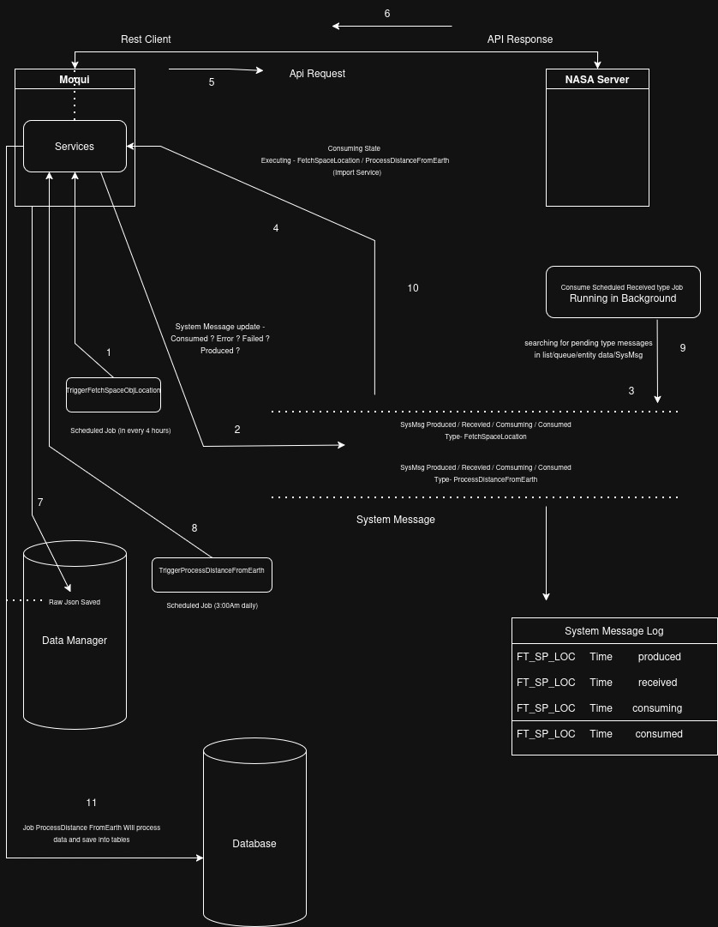

Flow -
First a scheduled job will run and add queue a message for API calling , it will create a produced status message - triggerProcessDistanceFromEarth every day.

Scheduled jobs will be running in background and look for their system message of their type and status to execute some task on it.

A Different job running in background will pick the produced status message on Queue and perform next step of consuming the message where we will call multiple services it may be general or specific.

While our api call and data processing is in progress other produced status message will also be processing cause their are crons expression and services which will be running concurrently and do their specific task.

When we are done with api the message status and raw data saved to data manager.
Now comes a different job which will process the data from data manager and save it to database for end user.

All the logs which have status and details of system message are in system message log.

When a particular service linked with system message overflow the fail count we dont process further and log the error and move. A different error status service will be running in background takes the responsibility and handle it according to our logic.

This is how system is configured for fault tolerance and always working on tasks.

v

